**From Dec-O-Art catalog where we currently order from:**

**MSO**

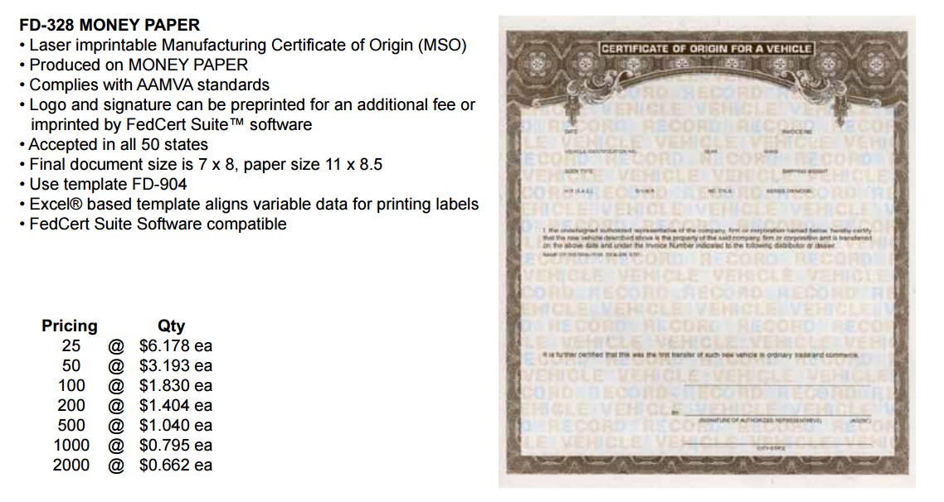

**Tire placard and VIN label combos:**

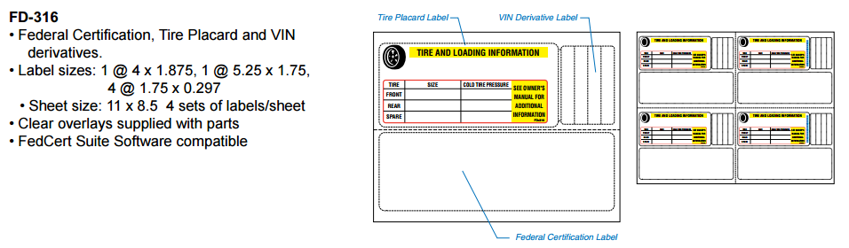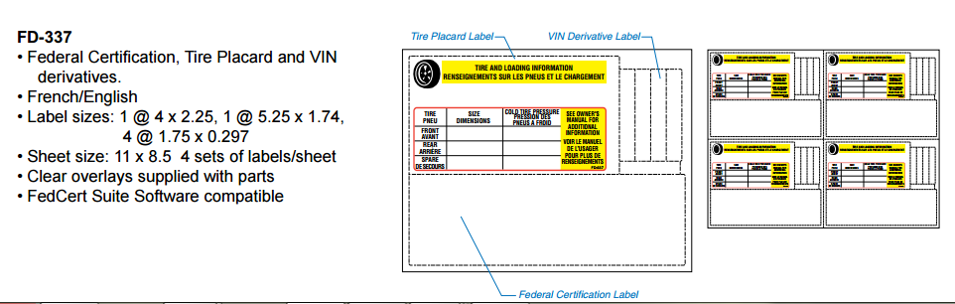

**Individual labels:**

